

PROJECTS ON SOFTWARE ENGINEERING

CS003

Initial Idea Paper

Project Title:

A PC Software for 3D Face Reconstruction

mapping into Game Model

LEI RUIJIA 1709853U-I011-0012

WANG HAOXU 1709853E-I011-0032

XU TIANHAO 1709853J-I011-0223

YUE ZHAOKE 1790853U-I011-0066

# Instructor professor: Subrota Mondal

**Project Title:**  A PC Software for 3D Face Reconstruction mapping into Game Model

**Group Information:**

LEI RUIJIA 1709853U-I011-0012 1709853ui011001@student.must.edu.mo

WANG HAOXU 1709853E-I011-0032 1026839618@qq.com

YUE ZHAOKE 1790853U-I011-0066 yzk9950218@gmail.com

XU TIANHAO 1709853J-I011-0223 573152970@qq.com

**Programming languages:**

Python, 3D max script, C++

**1. Introduction**

In view of the emergence of several popular face-swapping softwares about few months ago, plus it can’t be neglected that with the development of technology, users in this internet age are more and more interested in customized products. An increasing number of people are interested in exploring and using applications that can be related to their own characteristics, rather than those pre-defined components by developers. Besides, there are all kinds of computer games all over the world but the facial expression of characters in games are very fixed and stiff. In order to make players involved better and improve the enjoyment and experience of users, after the observation of cutting-edge AI technology and drastic brainstorming in our group, we hit upon an idea, applying specific target face no matter users’ own faces, the faces of good friends, or even the faces of celebrities, can meet the need of imagination of customers by replacing the faces of the characters in games (almost including the face, stature, emotion with facial expression). We want to develop a software to make it convenient for users to get their 3D face model and can actually see their faces come into games.

Through our efforts, we finally got in touch with a game company (because we used to love playing with their products) and were allowed to use some of their character models and their game engine editor to help us achieve our goal.

Process overview (rough presentation):

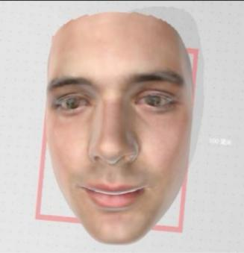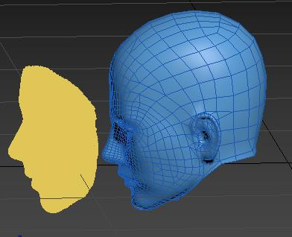

Target objectConstructing 3D model by AI Mapping our model to game

(model is provided by Seasun Game company)

**2. Expected List of Features**

Video import

Extract video into single picture per frame

3D face model reconstruction by specific video

Face model mapping

Generating animated effect on character model (face replacement and facial movement)

1. **Market and Demand Survey**

Local mobile apps like *FaceU, B612, Snow* and *ZAO* which mainly focus on the beauty function of photography and video recording have been widely used and this kind of apps are most mobile software. Moreover, there are many face-swapping apps, too. Almost those softwares focus on the 2D effect level. However, little of those softwares can do something for games, not to mention constructing a 3D face model, we find that relevant software is still scarce in the field we are considering. It means the work we do is meaningful.

We made an online questionnaire to find out what people thought of our software and whether they were interested in it or they have the demand or not.

The statistical result is shown as following (57 participants):

**#Are you interested in our project?** **#Do you have demand to use software like this?**

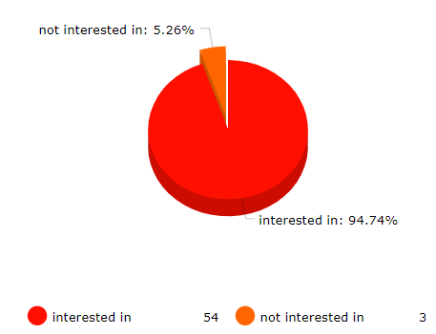 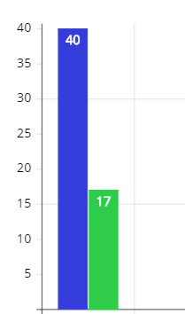

1. **Risk Analysis**

For analyzing risk of our application, due to the software needs a lot of computing and using neural network with AI technology, the first thing comes to mind is that it will take much time if the import video is too long, this requires patience, thus may reduce users’ favorability and make it not so easy to do some experience optimization. As what is aforementioned, we think the high requirements for computer system memory and computing capability is also a potential risk. Additionally, as for test environment, it is hard to confirm that the test environment has no risks. The reason is that software tester sets up test environment when do testing but it is not possible to be 100% identical to the user's environment, which means that there must be some risks, because some software defects can only occur under certain circumstances (including hardware, operating system, anti-virus software, patches for different versions of software, and actual data used by users). The solution is that tester needs to obtain the users’ data to test to prevent special risks. What’s more, the code quality is an important aspect. If submitted code is pretty terrible, so there are so many bugs which will lead to increase the difficulty of testing. The best way to address this problem is that we need to do adequate unit testing in the early stage.

1. **Competitive analysis**

5.1 Strategic positioning

|  |  |  |
| --- | --- | --- |
|  | Product positioning | User positioning |
| **Panxsoft** | Relying on the self-developed face shape and body shape identification tracking and data measurement technology, the company provides strong technical support for the marketing and personalized customization services of e-commerce / cosmetics / skin care / glasses / hairdressing / clothing / education industries. | Mainly serves for L'Oreal, Watsons and other beauty enterprises. |
| **Faceu** | Faceu is a camera made by today's headline face team and operated on IOS and Android platforms. It integrates the functions of sticker, filter, beauty, beauty, facial expression bag GIF production, post shooting editing and video tracking to provide young users with the experience of taking photos and recording videos; | The main group is young people, of which 78.36% are female users and 21.64% are male users |
| **MEGVII** | The world's leading artificial intelligence products and solutions company, focusing on the areas where algorithms can create great value:   face recognition, human body recognition, portrait processing, etc. | Smart financial industry represented by China Life Insurance. |

5.2 Product features

|  |  |  |  |
| --- | --- | --- | --- |
|  | 3D Face Reconstruction | Face detection | Emotion recognition |
| **1** | Real face model | Detect and locate the face in the picture | Analyze the emotion of the detected face |
| **2** | Fast modeling | Unlimited number of faces | Rich emotion recognition |
| **3** | Mapping real skin texture map | Multiple complex scene recognition | Provide emotional confidence |

1. **References**
2. Accurate 3D Face Reconstruction with Weakly-Supervised Learning: From Single Image to Image Set from <https://arxiv.org/abs/1903.08527>
3. Face Alignment in Full Pose Range: A 3D Total Solution

from <https://arxiv.org/abs/1804.01005>

1. How far are we from solving the 2D 3D Face Alignment problem (and a dataset of 230,000 3D facial landmarks) from <https://openaccess.thecvf.com/content_ICCV_2017/papers/Bulat_How_Far_Are_ICCV_2017_paper.pdf>
2. Joint 3D Face Reconstruction and Dense Face Alignment from A Single Image with 2D-Assisted Self-Supervised Learning from <https://arxiv.org/abs/1903.09359>
3. Game company <https://www.xishanju.com/> -> game page <https://jx3.xoyo.com/>
4. ZAO [Mobile application] from <https://www.tmtpost.com/4145180.html>